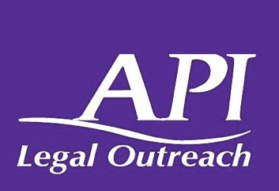
Asian Pacific Islander Legal Outreach - Small Business Clinic
1121 Mission Street
San Francisco, California – 94103
(415) 567-6255

Small Businesses in San Francisco:
Understanding Your Commercial Lease & Legal Rights

- What is a “Small Business” in California? Does my business qualify as a “Small Business”? In order to qualify as a small business, your business must be:
  - Located in California;
  - Has 100 or fewer employees;
  - Not dominant in its field of operations (not controlling or exercising major influence nationwide in a similar type of business activity); and,
  - Has average annual gross receipts of $10 million or less over the previous 3 years.

- What are the most important compliance issues that I need to pay attention to while operating a small business?
  - Are you paying all the required insurances on a yearly basis? (property, liability, worker’s compensation, unemployment insurances, etc.);
  - Have you paid your taxes? Are they up to date? (income, sales, payroll taxes, etc.);
  - Have you applied for required permits? ( zoning, health permits, environmental approvals, etc.); and
  - Are you maintaining good records and legal documents? (contracts, sales agreements, leases, purchase orders, service agreements, etc.).

- It is YOUR responsibility to be aware of the guidelines and the laws related to your business. Speak with an attorney to obtain a better understanding of compliance requirements.

- What is a lease? Why is it important?
  - A lease is a legal agreement between a landlord and a business tenant for the rental of property.
  - It is a legally binding written document outlining terms and conditions that a landlord and a business tenant are required to follow.
  - Carefully reviewing a lease BEFORE signing is extremely important.
  - An attorney can help you with making sure that the terms and condition are fair and reasonable to your interests and needs as a small business owner.

- Pay close attention to following lease provisions BEFORE you sign it :
  - Your legal right to “Quiet Enjoyment”: The landlord must not interfere or disturb your use of the property. Watch out for a provision that allows construction/renovation projects that may keep away potential customers.
  - Rent Increase: Carefully review the “rent escalation” provision. This gives your landlord the power to gradually increase the annual base rent based on an agreed calculation. (Ex. “your rent will increase by 3% each year.” Do you think you will be able to afford this?)
  - Repair/Maintenance provision clarifies who is responsible to maintain the leased property and pay for repairs. Inspect the property BEFORE signing the lease. Carefully review and negotiate what you will NOT be responsible for. You do not want to get stuck with expensive repair bills.
    - Ex) You run a restaurant. The ventilation system of the property is old and malfunctioning. Who will be responsible to upgrade it and pay for the cost?
    - Ex) You own a houseware/gift shop. The roof starts leaking and the rain has ruined the products in your shop. Who is responsible?

- Pay attention to the Common Area Maintenance (CAM) fees in a lease. CAM fees are expenses that landlords pass onto their tenants to help cover costs associated with overhead and operating expenses for common area. Understanding what expenses are included in CAM charges and how they are calculated is very important. Speak with an attorney to negotiate reasonable and fair fees. Common areas are spaces used for or benefited by all tenants, such as:
  - Hallways
  - Elevators
  - Parking lots
  - Lobbies
  - Public bathrooms
  - Building security, among others.

- Try to negotiate to include an early termination provision in a lease. If included, it allows you to terminate the lease before it is set to expire. Speak with an attorney to find the best way to terminate your lease with as little liability as possible. This provision can be helpful when:
  - Your business does not generate enough revenues as you hoped for;
  - You do not have enough money to keep up with the rent payments;
  - You want to start a new business;
  - The location of the leased property does not attract enough customers.

- I still cannot make my rent payments due to the economic hardship caused by the Covid-19 pandemic. How can the Covid-19 San Francisco Commercial Eviction Protections ordinance help me?
  - If you are a business with 49 or fewer employees, you may have additional time to repay any missed rent from March 18 2020 to September 30, 2021.
  - The ordinance provides you a forbearance period (repayment period) based on the below chart.

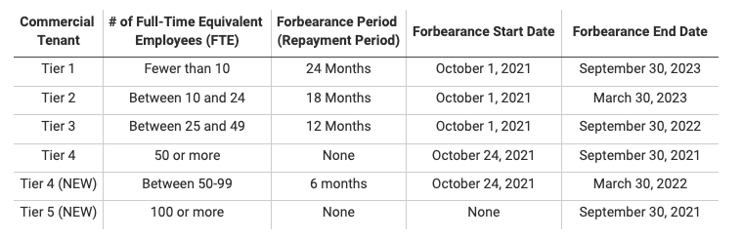

- It is important to speak with an attorney. If you have any questions regarding your commercial lease, or you are not able to make your rent payments due to the COVID economic hardship, please reach out to the following legal organizations.

