ASIAN PACIFIC ISLANDER LEGAL OUTREACH

September 21st, 2022
Board of Directors
David Huang
Deanna Kwong
Edith Ho
Elisa Shieh
Jane Gorai
Jerett Yan
Jesiros “Don” Bautista
Jessica Huang
Jinnhua Su
Lolita C. Kintanar
Neil Chan
Peter Lee
Stephanie Choy
Winnie Tsang

Staff
Akiko Takeshita
Alexis Bagon
Alicia Cuautle-Velazquez
Alyssa Gee
Annie Chen
Audrey Daniel
Claudia Reyes
Dean Ito Taylor
Derrick Figueras
Diana Rangel
Diane Matsuda
Esther Leong
Fanny Ho
Greg Palomares
Hannah Chung
Hee Jeong Matz
Hui Chen
Jason Truong
Jean Pham
Jeremy Chan
Julissa Santiago
Junko Kenmotsu
Kylie Tam
Lilia Arellano
Linda Li
Lorraine Yoshikawa
Marco Samson
Nancy Hing Wong
Patricia Vargas- Hernandez
Relfe Tan
Ren Shimizu Khan
Ruby Chan
Ted Tang
Thao Dang Weldy
Thu Le
Vanessa Campbell
Victoria Hartanto
Zohreh Moghadam

Re: Sponsorship Request for 47th Anniversary Celebration on October 21st, 2022

Dear Friends,

For the past 47 years, API Legal Outreach has provided legal and social services to the most vulnerable and underserved populations of the San Francisco Bay Area. Thanks to your generous support, this past year API Legal Outreach has responded to our communities’ needs by providing services to victims of anti-API hate violence and their families and continuing to help our cultural districts recover by helping small businesses.

We are excited to announce that our 47th Anniversary Celebration will be held on Friday, October 21st, 2022 at the San Francisco Design Center from 6PM-10PM.

For 47 years, our organization has remained dedicated to providing services that are both culturally and linguistically responsive to the needs of our communities. We ask for your generous support as an event sponsor in serving thousands in need, including:

    - Survivors of anti-API hate
    - Women and children suffering domestic violence, sexual assault, and other forms of gender based violence
    - Survivors of human trafficking
    - Immigrants fearing unjust incarceration and deportation
    - Elders facing physical and financial abuse
    - High school age youth building avenues to promote social justice
    - Vulnerable tenants facing eviction and lack of affordable housing
    - Small businesses, the foundation of our ethnic communities, facing eviction.

At a time when our communities continue to be vilified and attacked, with your partnership, we will continue to advocate for social justice and equal access to rights and protections under the law.

Sincerely,
Dean Ito Taylor
Executive Director
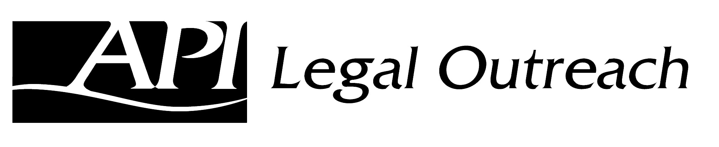
47th Anniversary Celebration
API Legal Outreach is a 501(c)(3) charity, tax ID 94-2583284,
all donations are tax-deductible to the extent allowable by law.

Sponsor Commitment Form

$10,000 Platinum or more donation
- 20 tickets to Gala
- 20 VIP gift packages (that will support API small businesses)
- Year-long acknowledgment on website, social media, and annual report
- Virtual access to event through the weekend
- Firm/company logo display and public acknowledgment at dinner
$7,000 Gold donation
- 12 tickets to Gala
- 12 VIP gift packages (that will support API small businesses)
- Year-long acknowledgement on website, social media, and annual report
- Virtual access to event through the weekend
- Firm/company logo display and public acknowledgment at dinner
$5,000 Silver donation
- 10 tickets to Gala
- 10 VIP gift packages (that will support API small businesses)
- Year-long acknowledgment on website, social media, and annual report
- Virtual access to event through the weekend
- Firm/company logo display and public acknowledgment at dinner
$3,000 Bronze donation
- 5 tickets to Gala
- 5 VIP gift packages (that will support API small businesses)
- Year-long acknowledgment on website, social media, and annual report
- Virtual access to event through the weekend
- Firm/company logo display and public acknowledgment at dinner
$1,500 Friend of APILO donation
- 2 tickets to Gala
- 2 VIP gift packages (that will support API small businesses)
- Year-long acknowledgment on website, social media, and annual report
- Virtual access to event through the weekend
- Firm/company logo display and public acknowledgment at dinner

Complete and submit this form to events@apilegaloutreach.org on or before October 8th to ensure acknowledgement and recognition before and during the event.
(Please print)
Sponsorship level _____________________________
Sponsoring business or organization (name to be acknowledged) _______________________________________________
Contact name ______________________________
Address ________________________________________________________________
Email _____________________________________

